

STM CLICK AND COLLECT PRE-LOVED UNIFORM

DATE:
PERSON REQUESTING ORDER:
CHILD/REN NAME:
CHILD/REN CLASS:

- complete and return the order form to admin@st-thomasmore.coventry.sch.uk
- you will be alerted when the order is ready for collection from the school office (if it is available)
- make payment (the correct cash) when you pick up your order from the school office

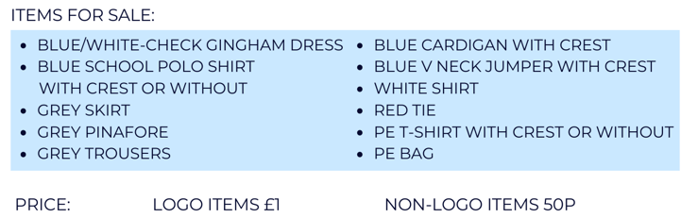

Item Description of item | Quantity | Size | Price | Total
 |  |  |  | £

